Lab – 2 Hugging Face 2
AI Question Answering System using Hugging Face

Step 1: Install Library
!pip install transformers

🔹 Step 2: Import and Load QA Model
from transformers import pipeline

# Load question answering model
qa_pipeline = pipeline("question-answering")

print("Model Loaded Successfully!")

🔹 Step 3: Give Context and Question
context = """
Hugging Face is a company that develops tools for building applications using machine learning.
It is well known for its Transformers library.
The company was founded in 2016.
"""
question = "When was Hugging Face founded?"

result = qa_pipeline(question=question, context=context)

print("Question:", question)
print("Answer:", result['answer'])

🔹 Step 4: Interactive Version
print("Enter your paragraph (context):")
context = input()

while True:
question = input("Ask a question (or type 'exit' to quit): ")

if question.lower() == "exit":
break

answer = qa_pipeline(question=question, context=context)
print("Answer:", answer['answer'])
print()

Title
Implementation of Question Answering System using Hugging Face Transformers

1. Aim
To develop a Question Answering system using Hugging Face Transformers that extracts accurate answers from a given paragraph based on user questions.

2. Objective
- To understand the use of pretrained NLP models.
- To implement a Question Answering pipeline.
- To perform inference using Hugging Face Transformers.

3. Theory
Hugging Face is an open-source AI platform that provides pretrained transformer-based models for Natural Language Processing (NLP).
The Question Answering (QA) model works by:
- Taking a context paragraph as input.
- Taking a question related to that paragraph.
- Predicting the exact span of text that answers the question.
The model used internally is based on transformer architecture like BERT.
Transformers use:
- Self-attention mechanism
- Contextual embeddings
- Pretrained language understanding

4. Software Requirements
- Google Colab
- Python 3
- Transformers Library

5. Implementation
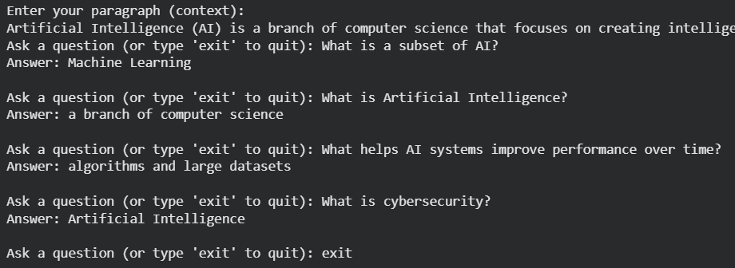


6. Sample Output
Example:
Context: Hugging Face was founded in 2016.
Question: When was Hugging Face founded?
Output: 2016

7. Applications
- Chatbots
- AI assistants
- Customer support automation
- Educational tools

8. Conclusion
The Hugging Face Transformers library provides an easy and efficient way to implement advanced NLP models. The Question Answering system demonstrates how pretrained transformer models can accurately extract information from text without manual rule-based programming.

